Main

Stanford/Elsevier's Top 2% Scientist Rankings

Stanford's Top 2% Scientists is an esteemed ranking that identifies the most cited scholars in their fields. This ranking, derived from Scopus database data, highlights researchers whose work has had a significant impact across various scientific disciplines.

Stanford University's list of "World's Top 2%" scientists is based on a 2% or above percentile rank, or the top 100,000 by c-score (with and without self-citations). This prestigious list identifies the world's leading researchers, representing approximately 2% of all scientists worldwide. It encompasses standardised data on citations, h-index, and a wide range of bibliometric indicators. Researchers are classified into 22 scientific fields and 174 sub-fields, drawing from Scopus data provided by Elsevier through ICSR Lab.

Methodology

The ranking is based on a composite indicator (c-score) calculated from six citation metrics:
- Total citations (NC)
- H-index (H)
- Hm-index (H-index adjusted for the number of authors)
- Citations to single-author papers (NCS)
- Citations to single or first-author papers (NCSF)
- Citations to single, first, or last-author papers (NCSFL)
- The c-score combines these metrics to provide a comprehensive measure of a scientist's impact, accounting for both the quantity and the quality of their contributions.

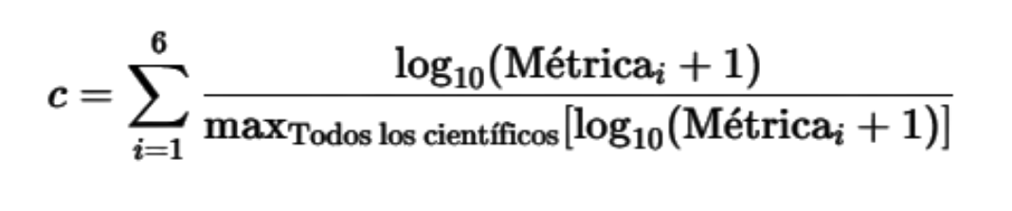
Fórmula del C-score:
“Max Todos los científicos” se refiere al valor máximo obtenido por un científico (Top 1) respecto a la métrica evaluada. Por ejemplo:

Citaciones Totales (NC):
- Científico X: Tiene 10,000 NC.
- Científico Top: Es el científico más citado en el mundo y tiene 200,000 NC. (Este es el valor máximo usado en la fórmula).
Para cada métrica se tienen las siguientes definiciones:
- Number of Citations (NC):Total number of citations of a specified document published.
- Hirsch Index (H): Reflects the number of papers that have been cited a certain number of times (e.g., if your H-index is 20, you have 20 papers each cited at least 20 times).
Para el Hirsch Index, se ordenan (en orden descendente) las publicaciones por el número de citas recibidas, enumerándolas para identificar el punto en el que el número de orden coincide con el número de citas recibidas por una publicación. Este número constituye el índice h.
Ejemplo:
- Publicación 1: 40 citas (Orden 1)
- Publicación 2: 30 citas (Orden 2)
- Publicación 3: 25 citas (Orden 3)
- Publicación 4: 15 citas (Orden 4)
- Publicación 5: 12 citas (Orden 5)
- Publicación 6: 8 citas (Orden 6)
- Publicación 7: 7 citas (Orden 7)
- Publicación 8: 5 citas (Orden 8)
- Publicación 9: 4 citas (Orden 9)
- Publicación 10: 3 citas (Orden 10)
En este caso, la publicación 7 tiene un orden de 7 con 7 citas. Por lo tanto, el último punto donde el número de orden es igual o menor al número de citas es la publicación 7. El índice h sería 7.
Fuente calculo del índice H (Universidad de Chile)

- Schreiber Co-Authorship Adjusted Hm Index (Hm): Adjusts the H-index for co-authorship, giving more weight to papers where you played a larger role.
Similar al Hirsch Index, para el Hm Index debemos ordenar las publicaciones de un autor en orden descendente por número de“citations” y se calcula el inverso de la cantidad de autores que aportaron a la publicación. El inverso calculado “weights” se suma acumulativamente y se almacena en “cweights”.
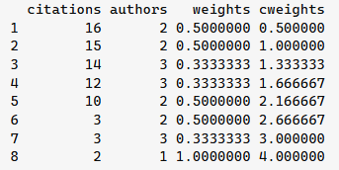
En el ejemplo de la tabla, el Hm Index corresponde a 3, porque 3 es el último valor de cweights en el que citations es igual o mayor a cweights.
Fuente cálculo de Hm Index (StackExchange)
- Citations to Single-Author Papers (NCS): Counts citations to papers where you are the sole author.
Número de veces en que se han citado artículos en donde se figura como Autor Único (sin colaboradores).
Fuente definición de NCS (University of Illinois Urbana-Champaign)
- Citations to Single or First Author Papers (NCSF): Counts citations to papers where you are the sole or first author.
Número de citas a papers donde se figura como el “first author”, incluyendo artículos donde se es el único autor (NCS) (métrica anterior a ésta). Un "first author" es donde el nombre del autor aparece al principio de la lista de autores, lo que generalmente indica que es la persona que hizo la mayor parte del trabajo, incluyendo la conceptualización del estudio, la redacción del manuscrito y la realización de la mayor parte de los experimentos.
Fuente First Author (Springer)
- Citations to Single, First, or Last Author Papers (NCSFL): Counts citations to papers where you are the sole, first, or last author, recognizing the importance of these positions in many disciplines.
Esta métrica incluye a las dos anteriores y corresponde a la suma de citaciones a artículos donde se corresponde al único autor, primer autor o último autor.
Debido a la dependencia de las tres métricas, se debería apreciar el orden de 4 < 5 < 6 al calcular sus valores.
Fuente definición de NCS (University of Illinois Urbana-Champaign)

Selection Criteria

Top 100,000 Scientists: Scholars are ranked based on their c-score, including and excluding self-citations. 2% Percentile: Scientists in the top 2% of their sub-field are also included. Field and Sub-field Classification Researchers are categorized into 22 scientific fields and 174 sub-fields based on the standard Science-Metrix classification.

Data and Updates

- Career-long Impact: Metrics cover the entire career of a scientist up to the end of current year-1.
- Recent Year Impact: Metrics focus on citations received during current year-1.
- Latest Version: This latest version is based on the Scopus snapshot as of October 1, current year.
- Transparency and Accessibility: This is a publicly accessible database that includes standardized information on citations, h-index, co-authorship adjusted hm-index, and the c-score. Metrics are available with and without self-citations, and field-specific percentiles are included for all scientists with at least five papers.
For more detailed information, visit the ICSR Lab.

About Our Data

The data presented on this website is sourced from Elsevier and Stanford University. We use this data under the Creative Commons Attribution-NonCommercial-NoDerivatives (CC-BY-NC-ND) license.
- Data Source: Elsevier
- License: CC-BY-NC-ND
- Original Data: [Elsevier Data Repository]

Our Role:

We have created a user-friendly interface to make this valuable data more accessible. However, we are not the creators of the data and are not affiliated with Elsevier or Stanford University in any way.

Usage Terms:

By using this website, you agree to comply with the terms of the CC-BY-NC-ND license. This means you may share the information provided here, but you must give appropriate credit, not use the material for commercial purposes, and not distribute modified versions of the data.

